ROBOT RESCUE
A RESCUE SERVICE GAME BASED ON DYNAMIC ROUTING

Leon J.M. Rothkrantz, Bogdan Tatomir, Luca Porzio
Data and Knowledge Systems Group

Faculty of Electrical Engineering, Mathematics and Computer Science

Delft University of Technology
Mekelweg 4, 2628 CD Delft, the Netherlands

E-mail: L.J.M.Rothkrantz@ewi.tudelft.nl, B.Tatomir@ewi.tudelft.nl

KEYWORDS
Dynamic routing, Ant Based Control, wireless ad hoc networks

ABSTRACT

In this paper we describe a game between a human player and a robot. The robot tries to escape from a labyrinth using a dynamic routing system. The robots are connected by a wireless network and are able to communicate about their position and blocked routes. The player can prevent the escape by blocking special routes. At every moment the player has a limited and at random varying number of blocks available. The game is implemented in the LEGO software environment. Our shortest path algorithm, named Ant Based Control (ABC-algorithm) is based on ideas from artificial life. The first prototype will be presented and the results of testing.

INTODUCTION

At Delft University of Technology there is a project running on dynamic routing. One of the goals of the project is to evacuate people out of a building or area in case of a crisis. Common rescue routes can be blocked by explosions, fire or terror attacks in a dynamically way.
Usually a rescue is based on a crisis plan and a static routing system. Visual icons show people how to reach the exit. In case of a dynamic changing environment the static routing system is not valid anymore, so a dynamic routing system is necessary.
Some people in a crisis area play a special role, such as policemen firemen or first aid helpers. The idea is to provide those people with handheld computers or PDA’s. On such a PDA a Personal Intelligent Rescue Service system (PIRA) is running. The information about the dynamic changing environment is provided by the PIRA’s itself. When a PDA meets a blocked route it can send a message containing the time and location of the block. Moving PDA’s are tracked by the Routing System. At regular times the PDA send a message containing the identity, time and position. So these PDA’s provide information about which routes are blocked and which routes are still open. Tracking the individual PDA’s provides also information about the travel time along the links.
One we know the travel times along the links in a graph from one node to the other we can compute the shortest path. Many algorithms are available such as the well known Dijkstra algorithm or A* algorithm. In this paper we introduce a new shortest path algorithm based on ideas from artificial life.
On request of an individual PIRA, the shortest path to the closest exit is computed and the PIRA user is routed along the shortest route. In case of dynamic changing the environment the PIRA computes the shortest path at regular times to provide the user by an up to date rescue route.
As a spin off of the project the rescue game was created. The RoboCupRescue project is an international cooperation to promote research and development in the socially significant domain of rescuing people. The game is inspired by the earthquake disaster in the city Kobe in Japan. In the game many disasters take place in the city of Kobe, ranging from earthquakes, fires, collapsing houses etc. The players have to organize rescue teams by robots. The winner is the team with the minimal amount of victims.
Our project is inspiered by and similar to the RoboCupRescue project. In our project the player plays the role of crisis generator. The player blocks roads by accidents, explosions etc. His goal is to prevent the rescue of the robots from the crisis areea. The chalange of the designers is to make the robot so smart that he is able to escape from the dangerous area under changing conditions.
At this moment we have a digital version of the game, which can even be implemented on a PDA and a more real life version using LEGO robots.
Our rescue game can be considered as a simulation of a real life situation. In the next section we will describe a dynamic routing algorithm based on the natural behavior of ants. Next we will describe our LEGO simulation environment.

LITERATURE

A large variety of path findings algorithm can be found in literature and most of them have their own advantages and disadvantages. Of the most important algorithm is the Dijkstra’s algorithm. The original algorithm was presented in 1959 and many successors appeared. Dijkstra’s algorithm aims at optimise one static parameter, which is the distance in our case. The extended Dijkstra algorithm is able to use dynamic information, but this implies that we need a way to collect dynamic information about the maze. In the best first algorithm a heuristic function is used which is able to estimate the distance between the current position and the goal.
The problem of all Pathfinding algorithms (Dijkstra included) is the enormous amount of resources (in memory needed and time complexity) they require. The A* algorithm works like the Dijkstra’s algorithm only it values the node costs in a different way. Each node’s cost is the sum of the actual cost to that node from the start plus the heuristic estimate of the remaining cost from the node to the goal. In this way, it combines the tracking of the previous length from Dijkstra’s algorithm with the heuristic estimate of the remaining path. The A* algorithm is guaranteed to find the shortest path as long as the heuristic estimate is admissible.

EXTENDED DIJKSTRA ALGORITHM

In Fig 1 we display the basic idea. In the X, Y-plane we show the basic topology or our labyrinth represented as a graph. Along the Z-axis we plot the time. At regular times (i.e. every second) we consider a horizontal layer with the graph of our network but with different weights of the edges and new or deleted links. So at regular times we have an adapted version of our graph and we compute the shortest path between possible nodes using Dijkstra. In this way the shortest route between two different nodes can change in the course of the time because of the changing travel times or changes in the topology of the network. At some time a 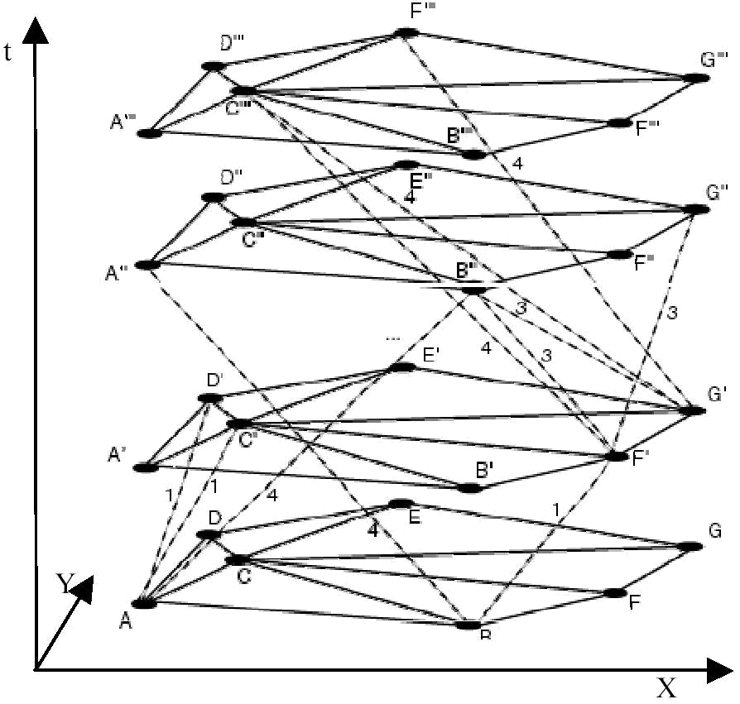
Figure 1: 3-dimentional graph
robot starts travelling from one node to another. When he has been arrived at the next node, he is switched to a different time layer with adapted routing tables. This approach places one constraint: the travel time has to be discretized to intervals. When using a very high sample rate an enormous graph is required, while a lower sample rate results in loss of information.
There are improved versions of Dijkstra's algorithm available adapted for dynamically changing networks, but we developed a new approach for dynamic routing which will be presented in the next section.

ANT BASED CONTROL ALGORITHM

This algorithm makes use of forward and backward agents. The forward agents collect the data and the backward agents update the corresponding probability tables in the associated direction. The algorithm consists of the following steps:
- At regular time intervals from every network node s, a forward agent is launched with a random destination d: F_{sd}. This agent has a memory that is updated with new information at every node k that it visits. The identifier k of the visited node and the time it took the agent to get from the previous node to this node (according to the timetable) is added to the memory. This results in a list of (k, t_{k})-pairs in the memory of the agent. Note that the agent can move faster than the time in the timetable.
- Each travelling agent selects the link to the next node using the probabilities in the probability table. The probabilities for the nodes that have already been visited by this agent are filtered out for this agent. Then a copy of the remaining probabilities is made for this agent and these probabilities are normalized to 1. Only this agent uses this temporary probability distribution to choose a next node, so the probability table is not updated yet.
- If an agent has no other option than going back to a previously visited node, the arising cycle is deleted from the memory of the agent.
- When the destination node d is reached, the agent F_{sd} generates a backward B_{ds}. The forward agent transfers all its memory to the backward agent and then destroys itself.
- The backward agent travels from destination node d to the source node s along the same path as the forward agent, but in the opposite direction. It uses its memory instead of the probability tables to find its way.
- The backward agent with previous node f updates the probability table in the current node k. The probability p_{df} associated with node f and destination node d is incremented. The other probabilities, associated with the same destination node d but another neighbouring node are decremented. The used formulas are given below.
The probability of the entry corresponding to the node f from which the backward agent has just arrived is increased using the following formula:
$P_{\text{new},f}=\frac{P_{\text{old},f}+ΔP}{1+ΔP}$ (1)
Here, P_{new,i} is the new probability, P_{old,i} the old probability and ΔP the probability increase. ΔP should be inversely proportional to the age of the forward agent. The formula we use is:
$ΔP=\frac{a}{t}+b$ (2)
Where a and b are constants and t is the trip-time of the forward agent from this node to the destination node. This trip-time is the sum of the trip-times from this node to the destination node of the forward agent. We do not take into account that the conditions of the traffic network can change from the moment that the node is visited by the forward agent and the updating of the backward agent.
The other entries in the probability table with the same destination but other neighbouring nodes are decreased using the formula:
$P_{\text{new},i}=\frac{P_{\text{old},i}}{1+ΔP}, ∀ i≠f$ (3)
These formulas ensure that the sum of the probabilities per destination remains 1. Probabilities can only decrease if another probability increases. Probabilities can approach zero if other probabilities are increased much more often. This is not very desirable, because in time it may appear that the choice associated with that probability is the best at that time, but the agents will not detect it because they hardly ever take that route. This problem can be solved after analogy with the natural ants; they do not always use the pheromone trail as their guide, but sometimes just explore new routes. Therefore we introduce an exploration probability as a minimum value for each probability. An example could be 0.05 divided by the number of next nodes. After setting this minimum, the probabilities per destination are normalized to one again. This ensures that none of the entries in the probability table will approach zero.
For a given value of ΔP, the absolute and relative increase of P_{new} is much larger for small values of P_{old} than for large values of P_{old}. This results in a weighted change of probabilities. The probability tables are initialised with equal values in such a way that all the probabilities for one destination sum up to 1. The first agents do not have any information about routes, let alone the quality of the routes. The performance of the routing system will therefore be very bad and cannot be evaluated properly.
The quality of the routes found by the agents improves with time. At first the agents will find many cycles, but the number of cycles decreases as the probability tables are filled with information that is more accurate. Appearing congestion causes further adjustments. Finally the vehicles will be routed according to the highest probabilities in the tables. They do not have to explore other routes. They just want the best route.

LEGO SIMULATION ENVIRONMENT

The goal of our research project was to develop and test our rescue game under real conditions. To build a robot and simulation environment we used LEGO bricks (Robotics Invention Kit). The brain of the robot is a LEGO microcomputer called RCX brick. It can control up to 3 engines and can receive the input of three different sensors. It can be programmed so to react to external stimuli. It comes shipped with visual software and an ActiveX component called Spirit that takes care of interfacing the programmer with the RCX.
For assembling robots we can choose between a variety of sensors to use. We used two light sensors, which are able to sense the colour v (in greyscale) of the object they are aiming to. Using these sensors the robot is able to follow a track (a black line). We used touch sensors as bump sensors. For the movement of the robot two motor bricks have been used. These motors cover the role of actuators in the robot. It is provided with gears so it can change velocity (from 0 to 7) and switch direction.
The RCX communicates with the PC via an Infrared (IR) Transmitter. This transmitter is attached to the serial port of the computer. An interface between IR sensor and programming language is provided by Lego by mean of an ActiveX control that is called Spirit. The Spirit ActiveX control is able to compile code, which will be uploaded onto the RCX for a completely autonomous execution or send direct commands to it through the IR sensor.

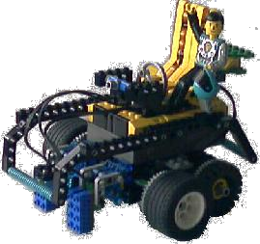
Figure 2: The Lego robot used in our lab simulation

Environment

To build an environment we created a labyrinth, a white sheet with black lines. The minimum requirements for a moving robot are: knowing its position, capabilities of understanding bumping situation and communication with the server and executing commands. To make sure the robot gets stick to its path we used two light sensors. One of these sensors is used to know where the robot is on a track, the other sensor is used to decide if the robot has arrived on a crossing. To resemble distance sensors we used a touch sensor. This sensor switches on when the robot touches something: a zero-distance sensor. If the robot bumps into something a blocked road or another robot then the robot knows that road is obstructed and has to find another path.

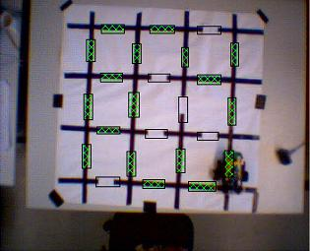
Figure 3: Image acquired from the camera
The limited capabilities of the RCX led us towards a centralized approach. During the research, we uploaded onto the RCX only the code needed for navigation and state generation code. The program uploaded onto the RCX is able to handle the information coming from sensors and translate them in knowledge about the current state of the robot. In this way the robot is able to accomplish taks like following a line drawn on the floor, deciding if it has reached a cross and turn on a cross according to the server information. A computer covers the server role. On this computer the routing system is running. Moreover the robot is able to sense an obstacle on its way, through the bumper sensor and sends this message to the server. In the same way it sends at regular time its position to he server.
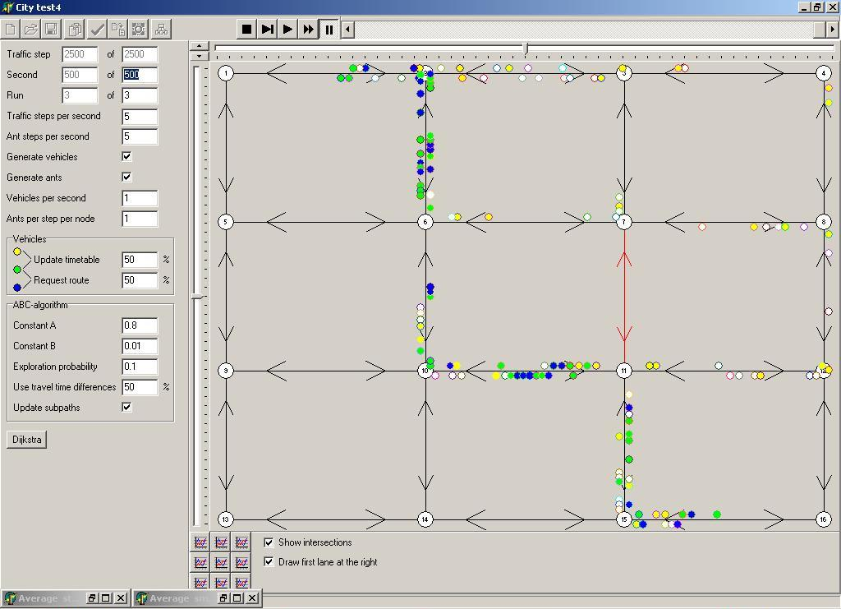
Figure 4: Simulation environment

EXPERIMENT

The goal of our robot is to rescue from the labyrinth. The player tries to block the roads as indicated in Fig 3. A limited number of blocks are available and the player can change the position of the blocks constantly. In the digital version of the game, blocks have a limited lifetime. In a first experiment we want to test the adaptability of the Routing system when some roads are disabled. When the Routing system is in an optimal state and the state of the traffic network changes, the Routing system has to adapt to the new situation. This is done by the agents: they constantly move through a virtual traffic environment and change the probability tables. By judging whether they have found good routes, they increase the probabilities for that route more or less. We would like to measure the time it takes for the Routing system to adapt to the new situation.
The traffic network is a grid with 4 x 4 intersections (see figure above). All the vehicles in the simulation will drive from the road between intersections 1 and 2 to the road between intersections 15 and 16 or vice versa from 15/16 to 1/2. This is accomplished by setting the source and destination rates of all other roads to zero. Because all roads have the same length and maximum speed there are four possible routes the traffic could take to accomplish the shortest travel time. Indicated by the numbers of the passed intersections, these routes are:
- 2 – 3 – 7 – 11 – 15
- 2 – 6 – 7 – 11 – 15
- 2 – 6 – 10 – 11 – 15
- 2 – 6 – 10 – 14 – 15
The vehicles driving from the road between intersection 15 and 16 to the road between intersections 1 and 2 should

choose the reverse order of one of these routes. When computing the shortest path with the built-in Dijkstra’s algorithm, the first one is chosen as the shortest route (in time). This does not mean that the other routes are longer, but just one has to be chosen and this happens to be the first. All vehicles that do not use the Routing system will use this route. The vehicles that do use the Routing system will initially also use this route, because the initial state of the Routing system is copied from these static routes. So in the beginning all vehicles will be driving via intersections 2, 3, 7, 11 and 15 (or in reverse order). Now we will disable the roads between intersections 7 and 11 (one road in each direction) as if there was a roadblock because of an accident or roadworks. The vehicles that do not use the Routing system will choose a random alternative when arriving at the blocked road. In most cases this means that the vehicles will take a longer path than necessary. The vehicles that do request the Routing system for a route, will probably make that same mistake at first. But the Routing system can adjust this route dynamically.
We display the different traveling times between dynamic routing and static routing systsystems in the following graphs.

Figure 5: Average standard route time
Figure 6: Average smart route time

CONCLUSION AND FUTURE WORK

We have created two prototypes of our robot rescue game. The first prototype is a digital version of the game and is based on a simulation of labyrinth with moving agents as robots. The second prototype the game uses real Lego-robots and the simulation environment of Lego. In the real or simulated environment of the labyrinth the moving robots send information about their position. This information is used to make assessments about the travelling time along the links. The labyrinth world is changing during time. Players can block or de-block different routes. The speed of different robots is changing in time too.
The kernel of the game is the dynamic routing system. We adapted the Ant Based Control system to our game. This ABC algorithm shows an enormous reduction in travelling time of the robots if we compare it with a static routing system. In the current system the routing system is implemented on a central server. Now all the communication of the robots is routed via the central server. In the next future the system will set up an ad hoc wireless network between the robots connected via a virtual communication layer. Then the routing system will also run on this wireless network. The situation will be more complex because of the dynamic character of the communication network too. Robots can join the network or leave the network. But we have to guarantee that robots are optimal routed based on the information provided by the robots itself in the (sub-) network. The data and the routing system have to be distributed along the processing devices of the robots itself.

References
G. Di Caro and M. Dorigo. AntNet: distributed stigmergetic control for communication networks. Journal of Artificial Intelligence Research (JAIR), Volume 9, pages 317-365.
H.K. Chen. Dynamic travel choice models: a variational inequality approach. Springer, Heidelberg, 1999.
T. H. Cormen, Introduction to Algorithms,2000, ISBN: 0-262-53091-0.
G. Eggenkamp, LJ.M. Rothkrantz. Inteligent dynamic route planning. BNAIC 2001, Amsterdam.
J.R. Evans and E. Minieka. Optimization algorithms for networks and graphs. Marcel Dekker Inc., New York, 2nd edition, 1991.
L.R. Ford and D.R. Fulkerson. Flows in Networks. Princeton University Press,Princeton, New Yersey, 1962.
R. Kroon, L.J.M. Rothkrantz. Dynamic vehicle routing using an ABC-algorithm, Proceedings of the Conference “Transportation and Telecommunication in the 3rd Millenium”, Prague, 2003, Czech Technical University of Prague.
B. Ran and D.E. Boyce. Modeling dynamic transportation networks: an intelligent transportation system oriented approach. Springer-Verlag, Berlin, 2nd edition, 1996.
L.J.M. Rothkrantz, J.C. Wojdel, A. Wojdel, H. Knibbe. Ant based routing algorithms, Neural Network World, Volume 10, 2000, pages 455-462.
R. Schoonderwoerd, O. Holland, J. Bruten, L.J.M. Rothkrantz. Load balancing in telecommunication networks, Adaptive Behaviour, 5, 2 , 1997.
J.M.P. van Waveren, L.J.M. Rothkrantz, Artificial player for Quake III Arena, Game-on 2001, London 2001, SCS Europe Bvba

